**Week #2**

**Understanding Persistent and Non-persistent HTTP Connections**

|  |
| --- |
| **To understand persistent and non-persistent HTTP connections and corresponding performance impact.**  Create a web page with N (e.g. 10) embedded images. Each image should be of minimum 2 MB size. Configure your browser (Firefox) with following settings (each setting requires repeat of experiment)   * Non persistent connection * 2 persistent connections * 4 persistent connections * 6 persistent connections * 10 persistent connections.   **Observation:** Note down the time taken to display the entire page in each of the settings. Ensure that (cache is cleared before starting the web request). Explain the response time differences. What is the optimal number of persistent connections for best performance?  Explain your answer. |

**Introduction**

The Apache HTTP server is the most widely-used web server in the world. It provides many powerful features including dynamically loadable modules, robust media support, and extensive integration with other popular software.

**Objective:** Understand persistent and non-persistent HTTP connections and corresponding performance impact.

**Experiment:** Create a web page with N (e.g. 10) embedded images. Each image should be of minimum 2 MB size. Configure your browser (Firefox) with following settings (each setting requires repeat of experiment)

1. Non-persistent connection
2. 2 persistent connections
3. 4 persistent connections
4. 6 persistent connections
5. 10 persistent connections

**Note down the time taken to display the entire page in each of the settings. Ensure that cache is cleared before starting the web request. Explain the response time differences. What is the optimal number of persistent connections for best performance? Explain your answer.**

**Note:** To install Apache server, use the following command,

**sudo apt-get install apache2**

If there is any error during installation, update the package manager by issuing the command,

# sudo apt-get update

**EXECUTION STEPS**

**Step 1:** Connect 2 desktops using switch and cables as shown below. (Use 2 VMs on Virtualbox or VMware instead of physical connections.)

**Server Client**

172.16.10.1/24

172.16.10.2/24



**Server Side:**

**Step 2:** Check your Web Server

At the end of the installation process, Ubuntu 16.04 starts Apache. The web server should already be up and running. We can check with the systemctl command to make sure the service is running by typing:

**sudo systemctl status apache2**

**or**

**sudo service apache2 status**

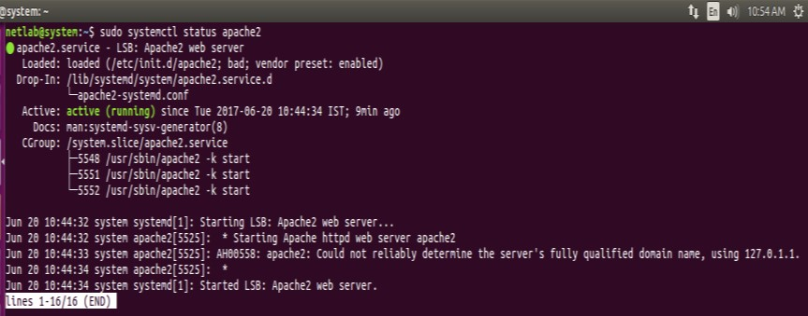

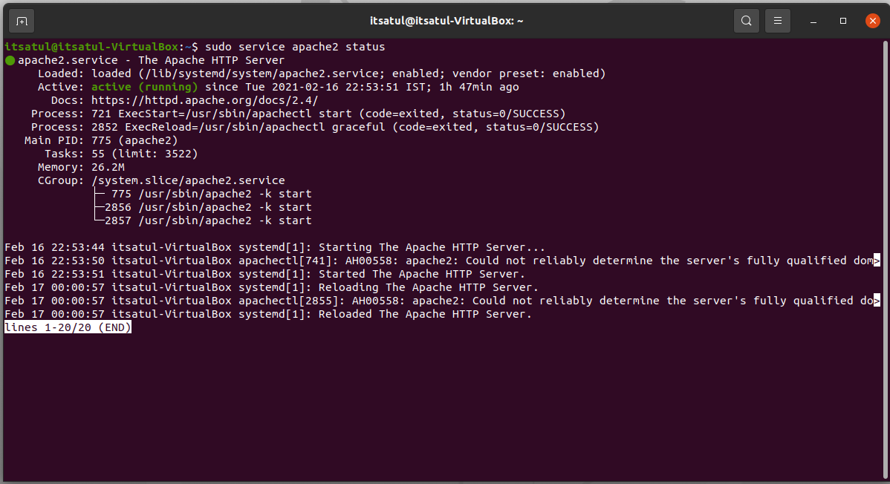



As you can see above, the service appears to have started successfully. However, the best way to test this is to actually request a page from Apache. You can access the default Apache landing page to confirm that the software is running properly. You can access this through your server's domain name or IP address.

**Step 3:** Server IP address can be set by the following command

**$sudo ip addr add 172.16.10.1/24 dev enps0**

**$sudo ip addr**

Note: If IP address fluctuates, kindly setup the IP address manually using ‘Edit connections’.

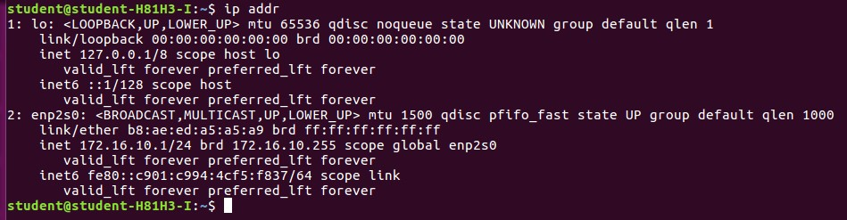

**Step 4:** The **apache2.conf** file present in the **etc/apache2** directory is modified as:

1. The **keep-alive** option was set (i.e. value was made **ON**)
2. The **MaximumKeepAliveRequests** were set to **2**

**$sudo nano /etc/apache2/apache2.conf**

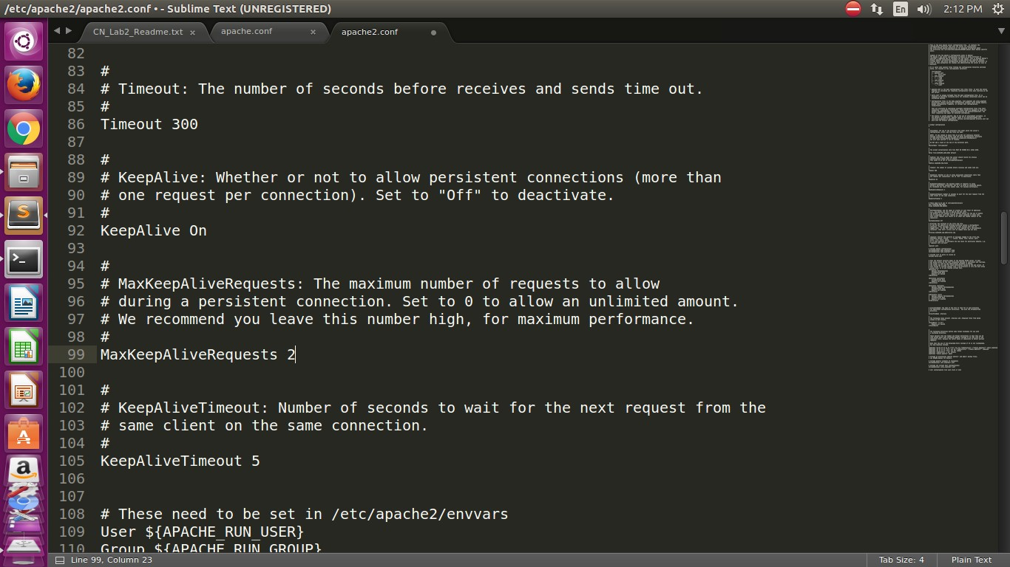

**Step 5:** Store images in the server path. A html page consisting of 10 images having size >

2MB were placed and accessed by the client. This html page is stored in the location - **/var/www/html/file_name.html**.

Note: Use the images provided by faculty incharges.



**Step 6:** Prepare a web page as shown below. The html file needs to add 10 images. (Kindly skip the style attribute in the below image)

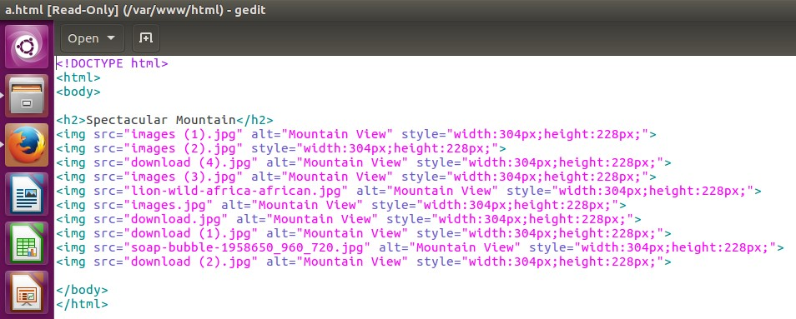

**Client side:**

Client IP address can be set by the following command.

**$sudo ip addr add 172.16.10.2/24 dev enps0**

**$sudo ip addr**

Note: If IP address fluctuates, kindly setup the IP address manually using ‘Edit connections’.

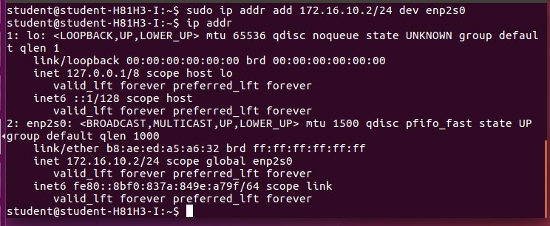

There are broadly two parts of execution:

1. Dealing with non-persistent connections
2. Dealing with persistent connections

Open Firefox browser to configure for persistent option. Go to browser andtype **about:config** and search for the term **‘persistent’**

* While using non-persistent connection experiment, the **max-persistent-connectionsper-server** has the value set to **0** and **persistent-settings** value set to false.
* While using persistent connection experiment, the **max-persistent-connections-perserver** should have value greater than 0 (depending on the number of persistent connections needed) and **persistent-settings** value set to true.

**PART 1: NON-PERSISTENT CONNECTION**

**Step 1:** This is done by setting the value of max-persistent-connection-per-server to 0 in the client computer.

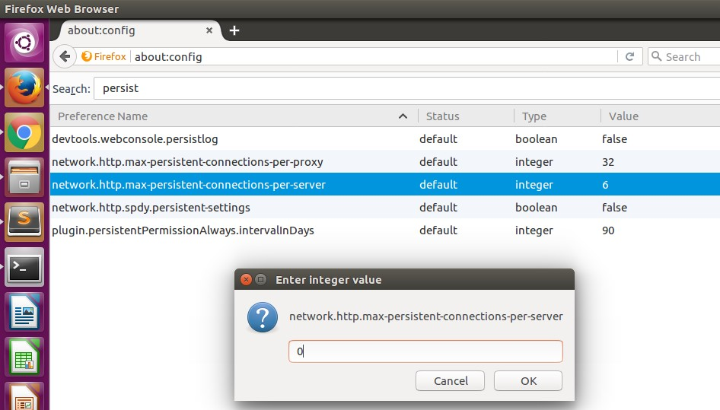

**Step 2:** Access web page on client-side browser (Firefox)

The client could access the file as:

**172.16.10.1/file_name.html** where**--> 172.16.10.1** is Server’s IP

Here the file name is **a.html** present in server. So, by tying **172.16.10.1/a.html** in client browser, we will be able to open the requested web page.

Note 1: The wireshark should capture the packets between the client and the server while the file is accessed.

Note 2: The images in the HTML page should have all the permissions specified through the server for the proper access.

**Step 3:** Use wireshark**.** Open wireshark in the server computer while client is trying to access the server’s local host webpage. Apply ‘http’ filter and note the time to capture all the 10 images.

In this case: 0.565122818-0.000679078=0.564443740

**PART 2: PERSISTENT CONNECTIONS**

Step 1: For 2 persistent connections, set the value of **max-persistent-connection-per-server to 2** in the client computer.

Step 2: Repeat the **steps 1-3** in the previous section.

In this case: 0.627776798-0.002395484=0.625381314

Step 3: For 4 persistent connections, Set the value of **max-persistent-connection-per-server to 4** in the client computer.

Step 4: Repeat the **steps 1-3** in the previous section.

In this case: 0.654611523-0.001133062 =0.653478461

Step 5: For 6 persistent connections, set the value of **max-persistent-connection-per-server to 6** in the server computer.

Step 6: Repeat the **steps 1-3** in the previous section.

In this case: 0.720885067-0.001659751=0. 739225316

Step 7: For 10 persistent connections, set the value of **max-persistent-connection-perserver to 10** in the client computer.

Step 8: Repeat the **steps 1-3** in the previous section.

In this case: 0.746488901-0.004136027 =0. 0.742352874

**OBSERVATIONS:**

|  |  |  |  |
| --- | --- | --- | --- |
| No. of Persistent Connections | Initial Time | Final Time | Total Response Time |
| 0 (Non-Persistent) | 0.565122818 | 0.000679078 | 0.564443740 |
| 2 | 0.627776798 | 0.002395484 | 0.625381314 |
| 4 | 0.654611523 | 0.001133062 | 0.653478461 |
| 6 | 0.720885067 | 0.001659751 | 0.739225316 |
| 10 | 0.004136027 | 0.746488901 | 0.742352874 |

Based on the observations, it is observed that load time for the non-persistent connection is faster than when compared to persistent connections. Furthermore, as the value of persistent connection is increased from 2 all the way to 10, it is observed that the load time for 10 images increase gradually.

The optimal persistent connection will be 2 as the load time for it is the fastest among all the values of persistent connections tested.

Why?